HW #2:

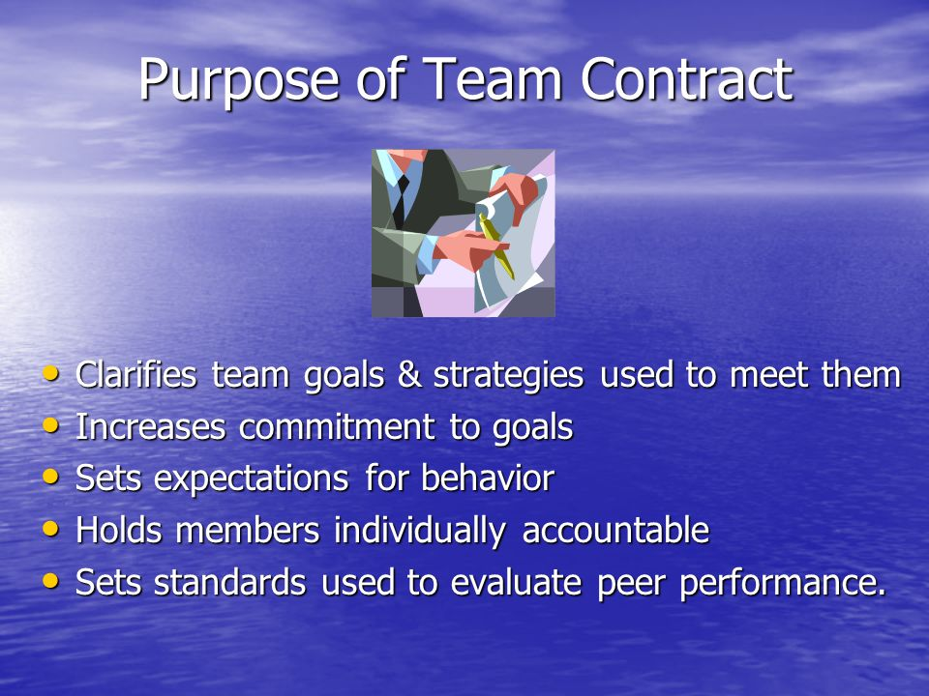
Meet as a team and discuss how you will work together as a team for the rest of the semester.
Here are the things that you should cover in your Team Contract:
- Team Members: List your team member names, contact information and majors / year of study
- Roles and Responsibilities: What roles will each team member play? Is there a lead? Who will interact with Sharon (it can be one person or all)? Who will be responsible for each of the different elements of the cost proposal?
- Team Execution Plan: How do you plan to approach your project? Describe how the team members will work together to create all the deliverables. How will you balance the workload? What commitments are you going to make to one another for completion of any aspect of the proposal that you are responsible for - i.e., will you deliver your portions of the project to other teams members in advance of the due date to ensure completeness and consistency? If so - how far in advance is each team member committing to completing / sharing their work?
- Team Communication: How does the team plan to communicate and share information with one another? How/when/where will you meet to get the project completed? What is the turn around time in communication with other team members (i.e. 24 hours)?
- Plan for Resolution of Team Dynamic Issues: How will you resolve issues that come up?
- Feel free to add any other relevant information that you feel is appropriate.
- Each team member should acknowledge and sign the contract (typed name is sufficient as long as every team member was part of developing the contract).

